

**UNIVERSITY OF PETROLEUM & ENERGY STUDIES**

**Dehradun**

**ACO LAB**

**Name – Ritik Kumar**

**Batch- 4 DEVOPS**

**Sap ID- 500097106**

**ROLL NO- R2142211330**

**SUBMITTED TO- Dr. Hitesh Kumar Sharma**

**Lab Exercise 10– Creating Deployment in Kubernetes**

Below is a lab exercise that demonstrates how to create and manage a Deployment in Kubernetes.

# Step 1: Create a Deployment Configuration File

Create a file named deployment.yaml with the following configuration: Link of file: (Coly following code from my GitHub repo) <https://github.com/hkshitesh/ACO-LAB-2021-25/blob/main/scripts/deployment.yaml>

apiVersion: apps/v1 kind: Deployment metadata: name: apache-deployment

labels:

app: web

spec:

replicas: 10 selector:

matchLabels:

app: web

template: metadata:

labels: app: web

spec: containers:

- name: httpd

image: httpd

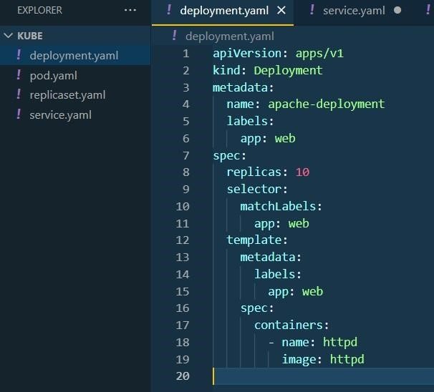

**Step 2: Apply the Deployment Configuration** Apply the configuration to create the Deployment: kubectl apply -f deployment.yaml

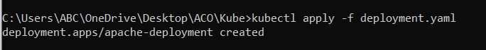

# Step 3: View the Deployment and Pods

View the created Deployment and the associated Pods:

kubectl get deployments

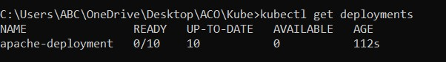

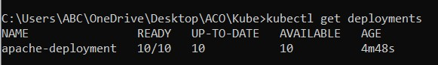

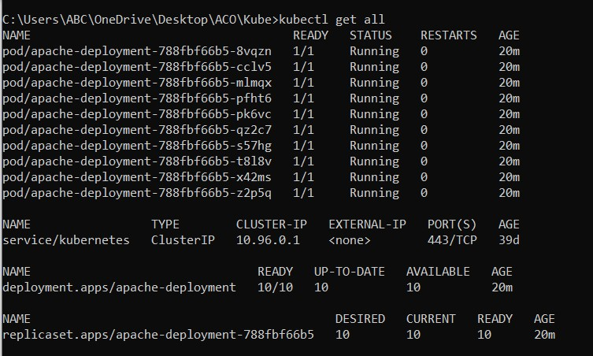

kubectl get pods

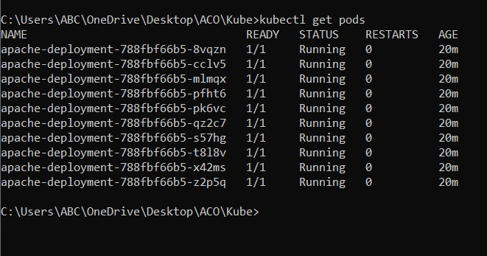

# Step 4: Delete the Deployment

Delete the Deployment:

kubectl delete deployment my-deployment

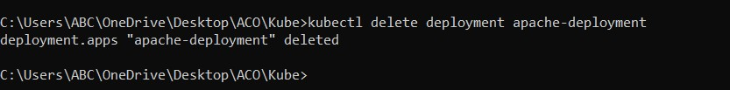

# Conclusion

This exercise demonstrated how to create, manage, and update a Deployment in Kubernetes. You learned how to scale the Deployment, update the image, and perform a rolling update to the Deployment. Experiment further with different configurations and update strategies to deepen your understanding of managing Deployments in Kubernetes.